<https://services.andhrauniversity.edu.in/Feetut/t-fee-all.php>

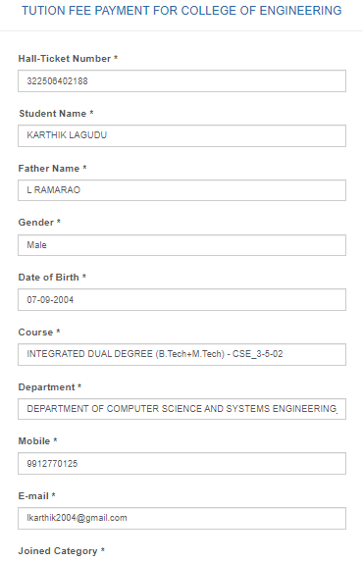

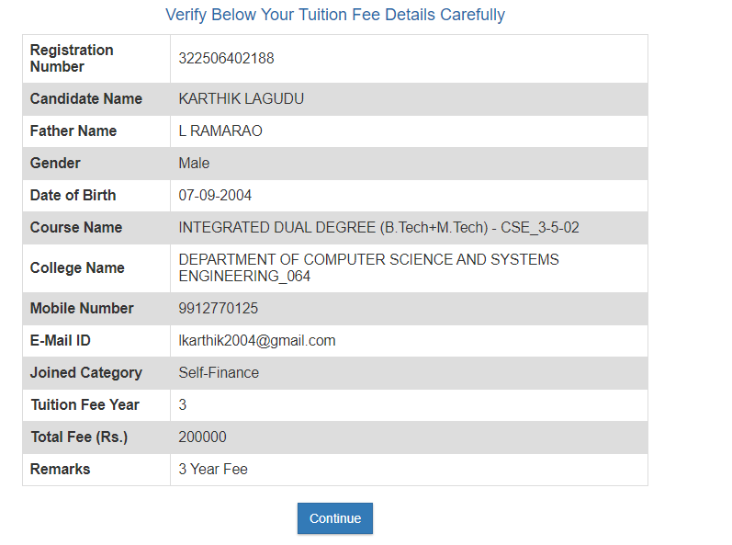  
  
**TF24ENGG29560**

|  |  |
| --- | --- |
| **Reference Number** | **TF24ENGG29560** |

